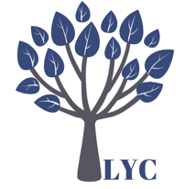
London Young Counselling

At Risk form

This document is to be used where there has been a disclosure of risk about a young person or vulnerable adult.
This document will also be used where they may be an allegation has been made against a member of London Young Counselling staff or volunteer.
Please write only factual information.
A copy of this document must be kept in the clients file and a copy filed with the designated Child Protection Officer.
Copies of any letters/emails written to a third party in relation to this disclosure must be kept with this document.

Date:

Date disclosure was made:

Name of person making the disclosure:

Name of person/counsellor receiving the information about the disclosure:

Young Person or Vulnerable Adult this disclosure is about.

Name:

Client Reference Number:

Date of Birth:

School:

Nature of concern:

Complete one of the two sections below.
Is this a direct disclosure between the two persons named above? Yes/No
Exact details of the disclosure.

Is this an indirect disclosure where there is a belief that there may be abuse? Yes/No
Details of the belief:

Action required
What action has been agreed to take this disclosure forward?

Who has this action been agreed between?

___________________________________ and ______________________________

By what date will this action have taken place? _______________________________

Who will follow up that this action has taken place? ___________________________

By what date? ________________________

Signature:__________________________

Notes of further investigation if applicable.

